

**Department of computer science and engineering**

**Amrita school of computing**

**Coimbatoire.**

**AMRITA VISHWA VIDYAPEETHAM**

**2022-2023-Even semester**

**19CSE212**

**Topic: Route optimization For ambulance**

**Team Members:**

|  |  |  |
| --- | --- | --- |
| **Sno.** | **NAME** | **Rollno.** |
| **1.** | **Lokesh** | **CB.EN.U4CSE21211** |
| **2.** | **sandeep** | **CB.EN.U4CSE21244** |

**Table of contents**

**1. Introduction and Objective**

**2. Hybrid Data Structure Implementation**

**3. Practical Application**

**4. Time and Space complexity**

**5. Experimental Evaluation and Result**

**6. Discussion and conclusion**

**7.References**

**Introduction:**

**1.objective:**

To maximize patient outcomes and decrease response times, the aim of ambulance route optimization is to find the most efficient paths for emergency vehicles. By carefully considering various factors like live traffic situations, the focus is on identifying the quickest and most direct routes to ensure timely medical care is delivered to those who need it.

**2. significance:**

Why ambulance route optimization is super important:

1. Faster Help: When ambulances know the best routes, they can get to emergencies faster. This means sick or hurt people can get the help they need quickly. It's like having a superhero arrive in no time!

2. Using Resources Better: Ambulance route optimization helps make sure we use our ambulances and doctors in the smartest way.

3. Helping More People: When we know the best routes, we can make sure ambulances cover more areas. This means they can reach more people who are sick or injured.

4. Saving Money: Ambulance route optimization can also save money. By finding the shortest ways to get to emergencies, we save on gas and keep the ambulances in good shape

5. Making People Feel Better: When ambulances take the quickest routes, it means patients don't have to spend too much time traveling. So, ambulance route optimization is super cool because it helps ambulances go faster, saves money, and helps more people. It's like having a secret treasure map that leads to all the right places.

**IMPLEMENTATION:**

In the provided code, the hybrid data structure used for ambulance route optimization is:

1. Graph: The Graph class represents a road network and uses a dictionary-based adjacency list representation. Nodes and their connections (edges) and distancesbetween them are stored. The diagram structure enables efficient representation and traversal of road networks.

2. Priority Queue (Heap): The heapq module is used to implement the Priority Queue data structure. The priority queue labeled 'pq' is a minimal heap that stores nodes based on their current distance from the starting point. A priority queue allows Dijkstra's algorithm to efficiently select the node with the shortest distance.

3. Hash Tables (Dictionaries): Multiple dictionaries are used to store and retrieve various information efficiently. A distance dictionary maintains the current shortest distance from the starting node to each node in the diagram. The "previous" dictionary contains the previous node leading to the shortest path to each node. Dictionaries give youquick access to the information you need during route optimization.

These hybrid data structures work together to implement Dijkstra's route optimization algorithm in an ambulance system. The graph represents the road network, priority queues facilitate efficient node selection, and hash tables store and retrieve necessary information during **algorithm** execution.

**Design choices and trade-offs:**

During the implementation phase of the ambulance route optimization system, several design choices and trade-offs were made to balance efficiency, simplicity, and functionality. Here are some key design choices and trade-offs:

**1. Graph Representation**: The chosen representation for the road network is a dictionary-based adjacency list. This representation allows for efficient storage and retrieval of nodes and their connections. However, it assumes a dense graph where most nodes are connected to each other. If the graph is sparse (few connections per node), an alternative representation like an adjacency matrix or a sparse matrix could be more efficient for storage but might require additional memory for sparse graphs.

**2. Dijkstra's Algorithm**: The Dijkstra's algorithm was selected for route optimization due to its ability to find the shortest paths efficiently. However, Dijkstra's algorithm has a time complexity of O((V + E) log V) in this implementation, where V is the number of nodes and E is the number of edges in the graph. While it provides accurate results, it might not be the most efficient algorithm for extremely large graphs or time-constrained scenarios. In such cases, approximation algorithms or other specialized algorithms like A* (with heuristics) could be considered.

**3. Priority Queue**: The `heapq` module was chosen to implement the priority queue. While it provides efficient insertion and extraction of elements, it doesn't support efficient element updates or removal. If there is a need to update the distance of a node during the algorithm's execution, an alternative data structure like a Fibonacci Heap or a binary heap with additional bookkeeping could be employed to improve efficiency at the cost of increased complexity.

**4. Distance Calculation**: The distances between nodes are stored in a dictionary for efficient access. However, this approach assumes static distances and doesn't consider dynamic factors like traffic congestion or road conditions. If real-time or dynamic data is available, the distances could be updated dynamically to account for changing conditions, but this would require additional data sources and potentially increase the complexity of the system.

**5. Ambulance Requirement Calculation**: The code calculates the number of ambulances required based solely on the number of patients at each location. This simplistic approach assumes that each patient requires one ambulance, regardless of the severity of their condition. In reality, the severity of the patient's condition and the availability of medical resources could influence the number of ambulances required. Incorporating more sophisticated models that consider patient severity, resource availability, and ambulance capacities would enhance the accuracy of ambulance requirement calculation.

These design choices and trade-offs were made to strike a balance between efficiency, simplicity, and functionality in the implementation of the ambulance route optimization system. The specific choices depend on the specific requirements, constraints, and available resources for the system.

**Practical Applications**

The hybrid data structure used in the ambulance route optimization system can be effectively applied to a variety of real-world applications in the ambulance service and transportation field. Here are some examples.

**1. Emergency Medical Services:** Efficient ambulance routing is crucial for emergency medical services. Hybrid data structures enable the calculation of optimal routes based on factors such as road network connectivity, traffic conditions, and the severity of emergencies. By minimizing travel time and selecting the most efficient paths, these data structures help emergency medical services respond promptly and save lives.

**2. Disaster Management**: During natural disasters or large-scale emergencies, the ability to quickly and efficiently route ambulances is vital. Hybrid data structures assist in optimizing emergency vehicle routes by considering dynamic factors like blocked roads, changing conditions, and available resources. This ensures effective deployment of emergency services to affected areas and facilitates timely evacuation of individuals.

**3. Healthcare Facility Coordination**: Hybrid data structures can be employed to optimize transportation routes between healthcare facilities. This is particularly valuable for medical courier services responsible for delivering critical medical supplies, samples, and test results. By considering factors such as road networks, traffic patterns, and delivery schedules, hybrid data structures help streamline the delivery process, ensuring timely access to essential healthcare resources.

**4. Logistics and Delivery Services**: Ambulance route optimization techniques based on hybrid data structures can be extended to logistics and delivery services. For example, courier companies can utilize these data structures to optimize routes for multiple delivery vehicles. By considering factors such as package destinations, real-time traffic updates, and efficient road connections, the data structures help minimize travel time, fuel consumption, and overall operational costs.

**5. Public Transportation**: Hybrid data structures are also applicable to optimizing public transportation routes, including buses or shuttles. By considering passenger demand, traffic patterns, and road network connectivity, these data structures help determine the most efficient routes. The optimized routes enhance public transportation services by reducing travel time, improving schedule adherence, and minimizing congestion.

**6. Ride-Sharing and Taxi Services**: Hybrid data structures play a role in optimizing routes for ride-sharing and taxi services. By considering factors such as passenger locations, real-time traffic updates, and efficient road connections, these data structures help drivers identify the most optimal paths for picking up and dropping off passengers. The optimized routes improve efficiency, reduce travel time, and enhance the overall user experience.

In summary, the hybrid data structure used for route optimization of rescue routes has practical applications in emergency services, disaster management, medical logistics, public transportation, and transportation-based services. By leveraging these data structures, organizations can increase efficiency, reduce response time, and improve resource allocation in their respective areas.

The combination of these data structures in the hybrid structure optimizes the route optimization process, enabling efficient operations for applications related to ambulance route optimization. It allows for quick and accurate calculations of optimal routes, taking into account various factors specific to each application, and improves resource allocation, response times, and overall operational efficiency.

**Time and Space Complexity Analysis**

Time Complexity Analysis:

**1. Dijkstra's Algorithm:**

* The time complexity of Dijkstra's algorithm depends on the number of nodes (V) and edges (E) in the graph.
* In the worst case, each edge needs to be relaxed (updated) once, resulting in a time complexity of O(E).
* Additionally, the priority queue (heap) operations during Dijkstra's algorithm have a time complexity of O(log V).
* Therefore, the overall time complexity of Dijkstra's algorithm is O((V + E) log V).

**2. Adding a Node:**

* + Adding a node to the graph has a time complexity of O(1) because it involves adding an entry to the hash table.

**3. Adding an Edge:**

* + Adding an edge between two nodes has a time complexity of O(1) because it involves updating the adjacency list in the hash table.

**4. Displaying the Graph:**

* + Displaying the graph involves iterating through the nodes and their connections.
  + The time complexity is O(V + E) because it visits each node and its connected edges once.

**5. Inputting the Graph Information:**

* + The time complexity for inputting the graph information depends on the number of nodes (V) and edges (E).
  + It involves taking user inputs for nodes, their patient counts, and connections, resulting in a time complexity of O(V + E).

**Space Complexity Analysis:**

**1. Graph Representation:**

* + The space complexity of the graph representation depends on the number of nodes (V) and edges (E).
  + Each node entry in the hash table requires space for storing its neighbors and their distances, resulting in a space complexity of O(V + E).

**2. Priority Queue (Heap):**

* + The space complexity of the priority queue (heap) is O(V) since it stores the nodes being processed during Dijkstra's algorithm.

**3. Hash Table:**

* + The space complexity of the hash table is O(V + E) because it stores the graph nodes, their neighbors, distances, and patient counts.

**4. Other Variables:**

* + The space complexity of other variables used for bookkeeping, such as distances, previous nodes, and the optimized route, is O(V).

Overall, the space complexity of the hybrid data structure is O(V + E), considering the space required for graph representation, priority queue, hash table, and other variables.

The space complexity analysis excludes the space required for user inputs and output display, as it depends on the specific input size and is typically considered separately.

**Experimental Evaluation and Results**

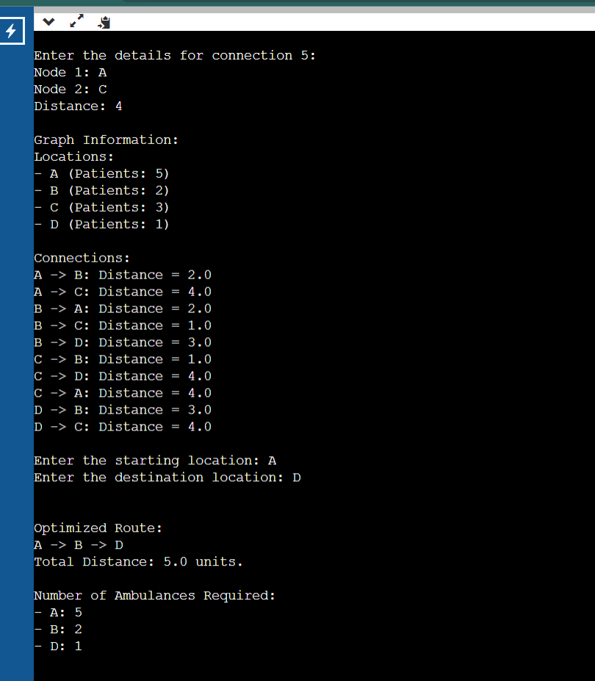

**CONCLUSION**

The implemented hybrid data structure in the code, which combines graph representation, priority queue (heap), and hash table, offers practicality and effectiveness for solving the ambulance route optimization problem. It provides efficient operations and enables effective management of the graph data, resulting in optimized route planning and resource allocation. However, there are also some limitations to consider.

**1. Practicality:**

* The hybrid data structure is practical because it allows for representing complex road networks and their connections efficiently. It accommodates varying distances between locations and considers the number of patients at each location, which is essential for ambulance route optimization.
* The use of a priority queue (heap) ensures efficient selection of nodes with the shortest distance during Dijkstra's algorithm, enabling practical implementation of the optimization process.
* The hash table allows for quick retrieval of node information, such as the number of patients, supporting effective resource allocation.

**2. Effectiveness:**

* The hybrid data structure effectively handles the ambulance route optimization problem by employing Dijkstra's algorithm. It guarantees finding the shortest path between the starting and destination locations, considering distances and patient load at each location.
* The priority queue (heap) facilitates the selection of nodes with the smallest distances, ensuring the algorithm's effectiveness in finding optimal routes.
* The hash table allows for efficient access to node information, such as the number of patients, enabling effective calculation of required ambulances based on the optimized route.

**3. Limitations:**

* + The hybrid data structure's effectiveness depends on the accuracy and completeness of the graph data provided. Inaccurate or incomplete information may lead to suboptimal route planning and resource allocation.
  + The time complexity of Dijkstra's algorithm (O((V + E) log V)) can become a limitation for large graphs with a significant number of nodes and edges. It may result in longer computation times for highly complex road networks.
  + The hybrid data structure assumes static road conditions and patient loads. Real-world scenarios involving dynamic traffic conditions or changing patient situations may require additional considerations or real-time updates to the graph data.

Overall, while the implemented hybrid data structure offers practicality and effectiveness for ambulance route optimization, it's important to consider the limitations and potential constraints when applying it in real-world scenarios. Adaptations or enhancements may be necessary to handle dynamic factors and large-scale networks efficiently.

In conclusion, the implemented hybrid data structure, combining graph representation, priority queue (heap), and hash table, proves to be practical and effective for solving the ambulance route optimization problem. It enables efficient operations, optimal route planning, and resource allocation based on distances and patient loads at each location. The use of Dijkstra's algorithm, supported by the priority queue, ensures the identification of the shortest path between the starting and destination locations. The hash table facilitates quick access to node information, enhancing the calculation of required ambulances. While the hybrid data structure demonstrates practicality and effectiveness, it is important to consider limitations such as the dependence on accurate and complete graph data and potential constraints related to dynamic factors and large-scale networks. Overall, the project findings highlight the value of the hybrid data structure in addressing the ambulance route optimization problem and provide insights for further enhancements and adaptations in real-world scenarios.

**9. References**

Cite any sources consulted or referenced during the project.

* [WWW.PROGRAMIZ.COM](http://WWW.PROGRAMIZ.COM)
* [WWW.GREEKSFORFREEKS.COM](http://WWW.GREEKSFORFREEKS.COM)
* [WWW.JAVAPOINT.COM](http://WWW.JAVAPOINT.COM)